Seventh Kyu – Orange Belt
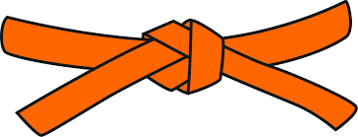
BASICS
KIHON WAZA – Basic techniques
- Junzuki - Lunge punch
- Gyakuzuki - Reverse punch
- Junzuki No Tsukkomi - Leaning lunge punch
- Gyakuzuki No Tsukkomi - Leaning reverse punch
- Maegeri Chudan - Front kick middle
- Mawashigeri Chudan - Roundhouse kick middle
- Sokuto Gedan - Side kick to shin
- Uraken Jodan - Back fist head
RENKEI WAZA – Combination techniques
- Maegeri Chudan, Mawashigeri Chudan, Gyakazuki Chudan - Front kick middle, Roundhouse kick middle, Reverse punch middle
- Gyakuzuki Jodan, Maegeri Chudan - Reverse punch head, Front kick middle

PAIR WORK
IPPON KUMITE - One step blocks
- Jodan Uke Ipponme & Nihonme - Head block One & Two
- Chudan Uke Ipponme & Nihonme - Middle block One & Two
- Maegeri Uke Ipponme & Nimonme - Kick block One & Two

KATA
Prearranged Form
Pinan Nidan

