3rd Dan – Black Belt
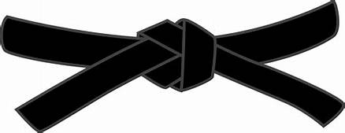
15 Minute written exam, covering various aspects of Karate
BASICS
KIHON WAZA - Basic techniques | RENKEI WAZA - Combination techniques
- Kette Junzuki  - Kette Gyakuzuki  - Tobikomizuki  - Nagashizuki  - Mawashigeri Jodan  - Sokuto Jodan  - Ushirogeri Chudan  - Tobigeri Chudan | - Surikomi Maegeri Chudan,Nagashizuki Jodan, Mawashigeri Jodan  - Sune-geri, Mawashigeri Jodan, Ushirogeri Chudan, Gyakuzuki Chudan
PAIR WORK
IPPON KUMITE - One step blocks
- Jodan Uke – Nihonme & Sanbonme
- Chudan Uke - Nihonme & Yonhonme
- Maegeri Uke - Gohonme & Ropponme
OHYO KUMITE – Semi-free fighting | APPLICATION OF KUMITE: Candidates choice
Ropponme, Nanahonme, Happonme  & Happonme Japanese Version | 2x Ohyo  2x Kihon
KIHON KUMITE – Basic Sparring
Nanahonme, Happonme, Kyuhonme
& Jipponme
KATA
Pinan Shodan, Kushanku, Niseishi, jittei & Jion

JI YU KUMITE

