1st Dan – Black Belt
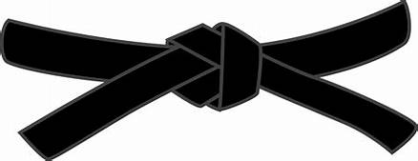
15 Minute written exam, covering various aspects of Karate
BASICS
KIHON WAZA - Basic techniques
- Kette Junzuki
- Kette Gyakuzuki
- Kette Junzuki-no-tsukomi
- Kette Gyakuzuki-no-tsukomi
- Nagashizuki
- Mawashigeri Jodan
- Sokuto Jodan
- Ushirogeri Chudan
RENKEI WAZA - Combination techniques
- Maegeri Chudan, Mawashigeri Chudan, Ushirogeri Chudan, Gyakuzuki Chudan
- Maegeri Chudan, Nagashizuki Jodan, Gyakuzuki Chudan, Mawashigeri Jodan
PAIR WORK
IPPON KUMITE - One step blocks
- Jodan Uke - Ipponme & Sanbonme
- Chudan Uke - Ipponme & Sanbonme
- Maegeri Uke - Ipponme & Sanbonme
OHYO KUMITE – Semi-free fighting
- Ipponme, Nihonme & Sanbonme
KIHON KUMITE – Basic Sparring
- Ipponme, Nihonme & Examiners choice between: Sanbonme, Yonhonme, Ropponme & Nanahonme
KATA
Pinan Shodan & Kushanku
Examiners choice between: Naihanchi, Seishan or Chinto

JI YU KUMITE

