Second Kyu – Middle Brown Belt
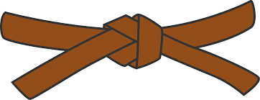
BASICS
KIHON WAZA - Basic techniques
- Kette Junzuki
- Kette Gyakuzuki
- Nagashizuki
- Maegeri Jodan
- Mawashigeri Jodan
- Sokuto Jodan
- Ushirogeri Chudan
- Tobigeri
RENKEI WAZA - Combination techniques
- Maegeri Chudan, Mawashigeri Chudan, Ushirogeri Chudan, Gyakuzuki Chudan
- Surikomi Maegeri Chudan, Nagashizuki Jodan, Mawashigeri Jodan
PAIR WORK
IPPON KUMITE - One step blocks
- Jodan Uke - Nihonme & Sanbonme
- Chudan Uke - Nihonme & Sanbonme
- Maegeri Uke - Nihonme & Gohonme
OHYO KUMITE – Semi-free fighting | KIHON KUMITE – Basic fighting
- Gohonme | - Sanbonme
- Ropponme | - Yonhonme

KATA
Kushanku, Naihanchi, Pinan Shodan

JI YU KUMITE

