Third Kyu – Junior Brown Belt
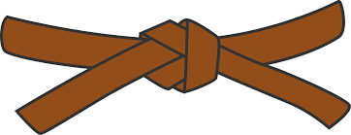
BASICS
KIHON WAZA - Basic techniques
- Kette Junzuki
- Kette Gyakuzuki
- Kette Junzuki No Tsukkomi
- Kette Gyakuzuki No Tsukkomi
- Tobikomizuki
- Nagashizuki
- Surikomi Mawashigeri Jodan
- Surikomi Sokuto Jodan
RENKEI WAZA - Combination techniques
- Tobikomizuki Jodan, Chudan Zuki, Surikomi Maegeri Chudan, Sokuto Chdan, Uraken Jodan
- Maegeri Chudan, Nagashizuki Jodan, Gyakuzuki Chudan, Mawashigeri Chudan
PAIR WORK
IPPON KUMITE - One step blocks
- Jodan Uke - Sanbonme & Yonhonme
- Chudan Uke - Sanbonme & Yonhonme
- Maegeri Uke - Sanbonme & Ropponme
OHYO KUMITE – Semi-free fighting | KIHON KUMITE – Basic fighting
- Nihonme | - Ipponme
- Yonhonme | - Nihonme

KATA
Kushanku & examiner’s choice of Pinan Kata, Pinan Shodan

JI YU KUMITE

