2nd Dan – Black Belt
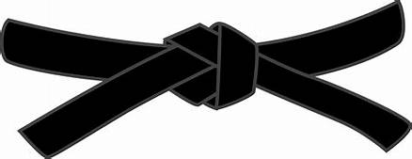
15 minute written exam, covering various aspects of karate
BASICS
KIHON WAZA - Basic techniques | RENKEI WAZA - Combination techniques
- Kette Junzuki  - Kette Gyakuzuki  - Kette Junzuki-no-tsukomi  - Kette Gyakuzuki-no-tsukomi  - Nagashizuki  - Surikomi Mawashigeri Jodan  - Surikomi Sokuto Jodan  - Ushirogeri Chudan | - Surikomi Maegeri Chudan, Sokuto Chudan, Ushirogeri Chudan, Uraken Jodan  - Zenshite Jodan, Chudan Zuki, Maegeri Chudan, Nagashizuki Jodan, Gyakuzuki Chudan, Mawashigeri Jodan
PAIR WORK
IPPON KUMITE - One step blocks
- Jodan Uke – Nihonme & Yonhonme
- Chudan Uke - Nihonme & Yonhonme
- Maegeri Uke - Nihonme & Ropponme
OHYO KUMITE – Semi-free fighting | APPLICATION OF IPPON KUMITE: Candidates choice
- Ipponme & Gohonme | 2x Jodan  2x Chudan  2x Maegeri
KIHON KUMITE – Basic Sparring
- Yonhonme
- Gohonme
- Ropponme
KATA
Pinan Shodan, Baisai & Wanshu
Examiners choice between: Niseishi or Rohai

JI YU KUMITE

